**Adesh Pandey 2014004**

**Rishabh Gupta 2014086**

**DBMS PRJOECT**

**ER DIAGRAM**



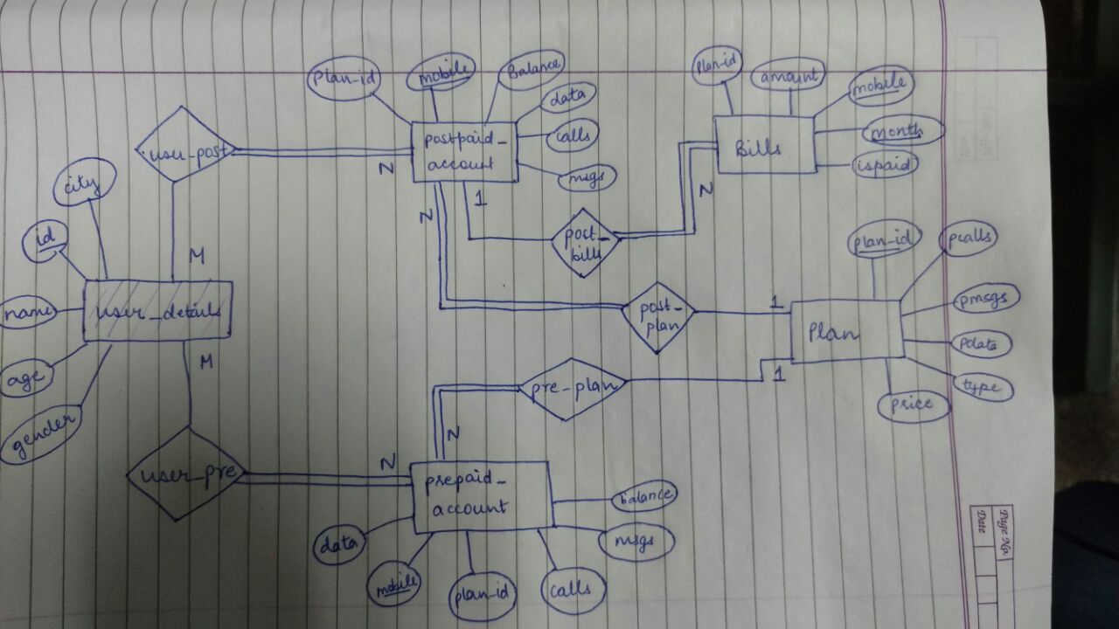

**RELATIONAL SCHEMA**

**user_details**(

id int primary key,

name varchar(50),

age int,

gender char ,

city varchar(50)

);

**user**(

id int primary key references user_details(id),

mobile bigint primary key

);

**prepaid_account**(

mobile bigint primary key references user_details(id),

balance int,

plan_id int references plan_details(id),

calls int,

msgs int,

data int

);

**postpaid_account**(

mobile bigint primary key references user(id),

plan_id int references plan_details(id),

calls int,

msgs int,

data int

);

**plan_details**(

plan_id int primary key,

pcalls int,

pmsgs int,

pdata int,

type char(20),

price int

);

**bills**(

mobile bigint primary key references postpaid_account(mobile),

month date,

amount int,

plan_id int,

ispaid boolean default false

);

**FUNCTIONAL DEPENDENCIES**

**user_details**

**id** -> id,name , age , gender , city

**prepaid_account**

**mobile** -> mobile,balance ,plan_id , calls , msgs , data

**postpaid_account**

**mobile** -> mobile,plan_id , calls , msgs , data

**plan_details**

**plan_id** -> plan_id, pcalls , pmsgs , pdata , type , price

**bills**

**mobile** ,month -> mobile, month, plan_id , amount, ispaid